maps-in-time overview

There are 3 levels of Flash file in the interactive.

Top level

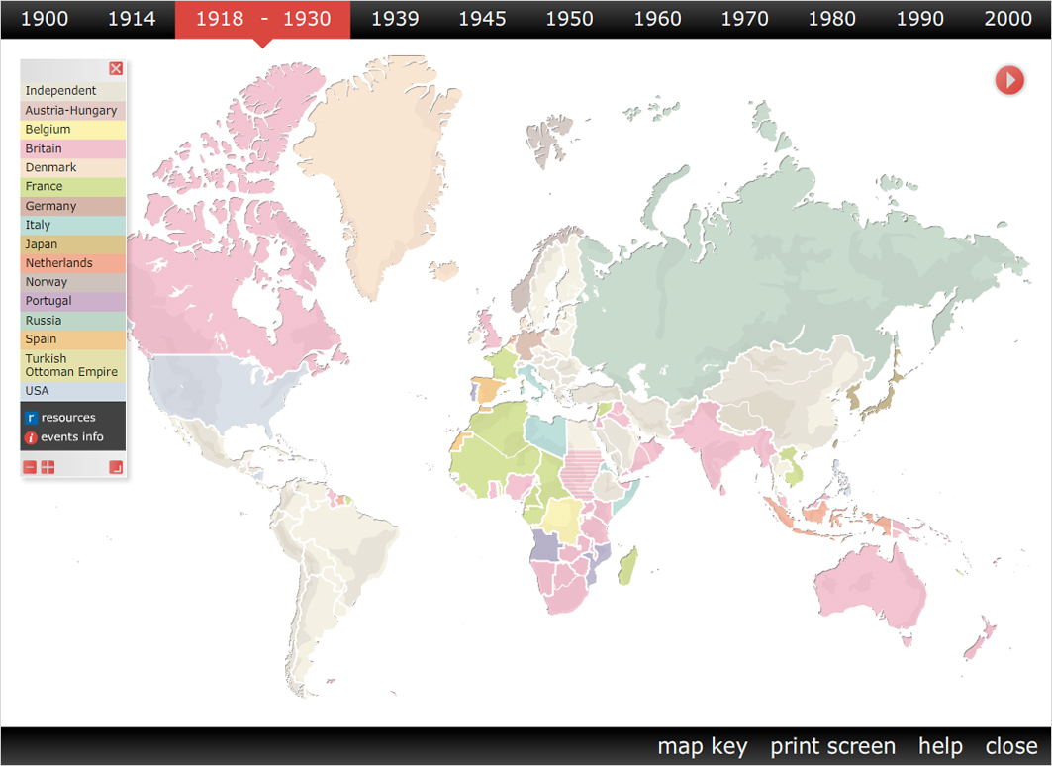

The top level file is called "maps-in-time.fla".

This file controls the interactive as a whole, and loads all the other files into itself, as and when they are needed. It is a complicated and intricate file, and should only be edited by someone with an in depth understanding of Flash and actionscript. In reality it should not need editing as edits to info point hotspots and resource bundles and hotspots are made in the other files.

Second level

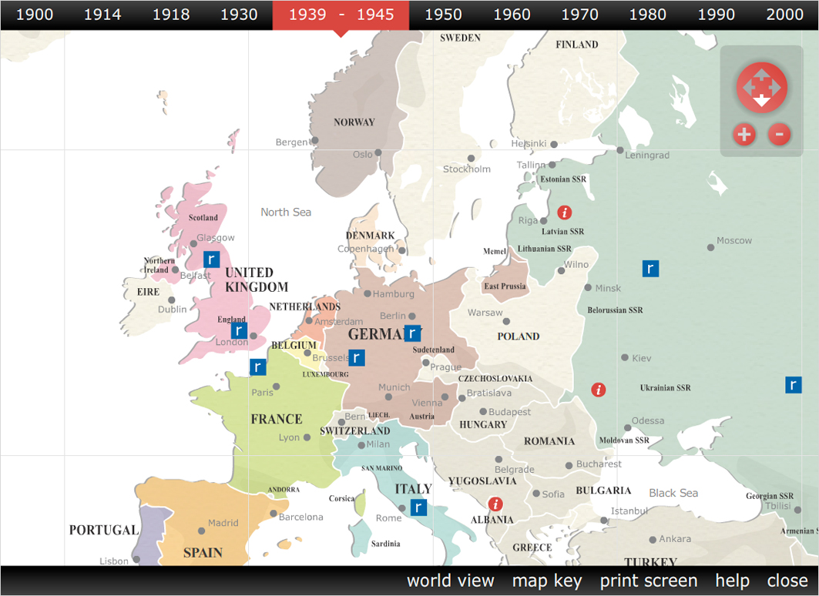

Next there are the 11 flash files containing the zoomed in maps (eg zoom-1914.fla contains the first map).

These 11 files also contain the hotspots for information and resource bundles. You would probably only need to open and edit these files if you wanted to add or edit hotspots.

Please note that the "world view" zoomed-out versions of the maps are contained within the main maps-in-time.fla file.

Third level

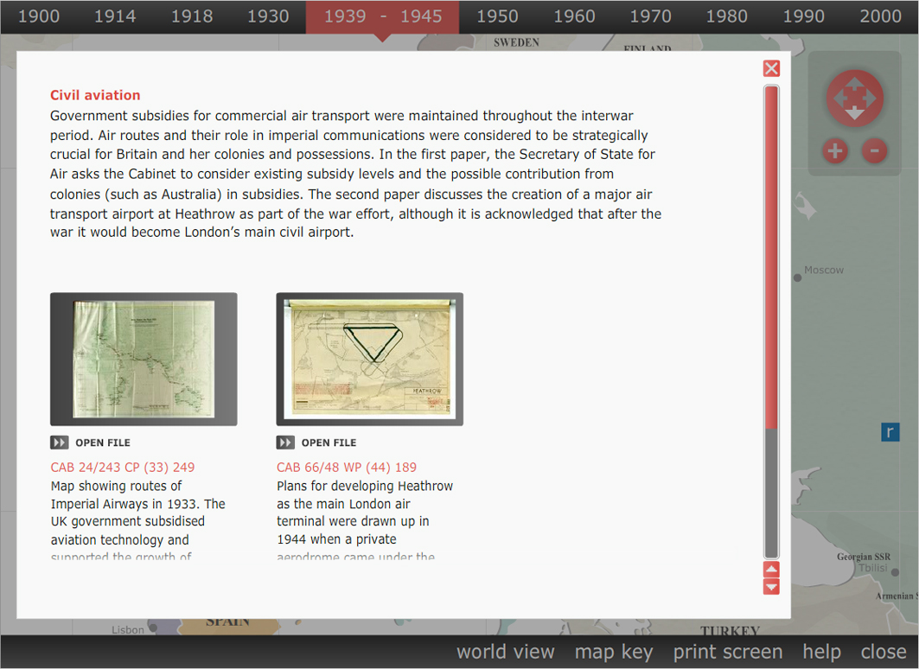

Finally there are a set of flash files containing the information for each individual resource bundle pop up window. These files are relatively simple, containing only the content of the pop up box for each bundle, and paths to the associated .jpg resource files.

They are kept in the "resource-details" folder, and have filenames like "18-northfrance.fla".

The associated .jpg resource files, to which these files link, are found in the "resource-downloads" folder.

